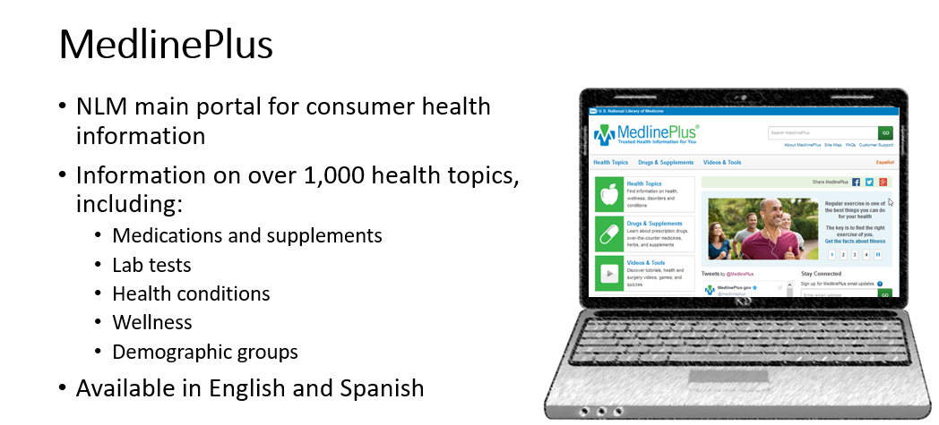

MedlinePlus Quality Guidelines
- Accurate, science-based information
- Information appropriate for MedlinePlus audience & easy to use
- List of links are reviewed
- Preference given to pages free from advertising
- Availability and maintenance of webpage
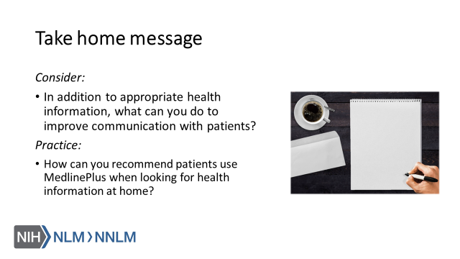

References:
- LaValley, Kiviniemi & Gage-Bouchard (2016). Where People Look for Online Health Information. Health Information & Libraries Journal, 34, 146-155.
- Sbaffi & Rowley (2017). Trust and Credibility in Web-Based Health Information: A Review and Agenda for Future Research. Journal of Medical Internet Research, 19(6), e218.

