Health Literacy in the U.S.
The National Assessment of Adult Literacy measured health literacy in adults 16+ in 2003^{8.} Results showed that only _______ % of English-speaking adults in the United States had proficient health literacy skills⁸.
Readability ≠ Plain Language ≠ Health Literacy
Readability measures the complexity of printed materials and plain language is communication that someone can understand the first time³. Addressing health literacy also means making the content understandable and __________________ for everyone⁴
Health Literacy Red Flags:
- Forms incomplete or incorrectly filled out
- Non-adherence to medication instructions
- Can’t name medications, purpose, or how to take
- Frequently __________________
- Anger
- “I forgot my glasses”
- “My wife, friend etc. usually takes care of…”¹

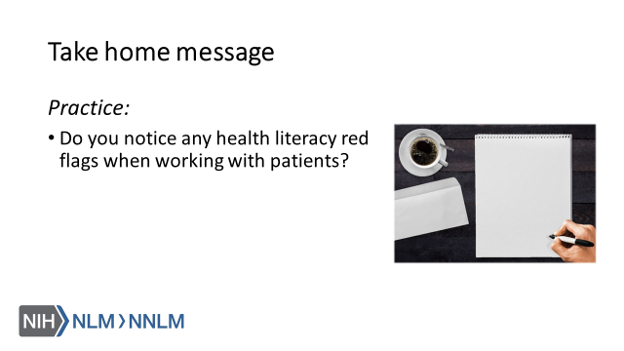
References:

- AMA Foundation (2007). Health literacy and patient safety: Help patients understand. Retrieved from URL to source
- Centers for Disease Control and Prevention (2016). Understanding Health Literacy. Retrieved from: URL to source
- Indian Health Service (n.d.). Healthcare Communications. Retrieved from: URL to Source
- National Academies of Sciences, Engineering, and Medicine (2016). Integrating health literacy, cultural competence, and language access services: Workshop summary. Washington, DC: The National Academies Press. doi:10.17226/23498.
- Office of the Legislative Council (2010). Compilation of the Patient Protection and Affordable Care Act. Retrieved from URL to source
- Plain Language Action and Information Network (2017). Plain Language Guidelines. Retrieved from: URL to Source
- University of North Carolina Chapel Hill (2014). Health Literacy Data Map. Retrieved from: URL to Source
- U.S. Department of Education (2006). The Health Literacy of America’s Adults: Results from the 2003 National Assessment of Adult Literacy. Retrieved from: URL to Source
- U.S. Department of Health and Human Services, Office of Disease Prevention and Health Promotion. (2010). National Action Plan to Improve Health Literacy. Washington, DC.: Author. Retrieved from URL to source

