Psychology of Scarcity
Scarcity focuses the mind automatically and powerfully on ____________________ needs and challenges^{7,8}
Cognitive Capacity (“Mental Bandwidth”)
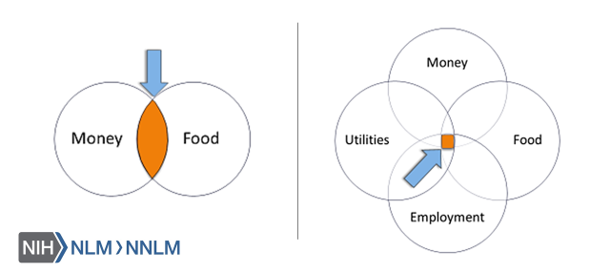

Scarcity & Chronic Stress
______________________ activation of the stress-response system can disrupt almost all of the body’s processes and increase the risk for numerous health problems³
Allostatic Overload
“…the cumulative biological burden exacted on the body through daily ________________ to physical and emotional _____________________”⁵
Allostatic overload can increase risk for:
- Depression
- Cognitive impairment
- Inflammatory and autoimmune disorders
- Coronary vascular disease
- ________________
- Diabetes⁵
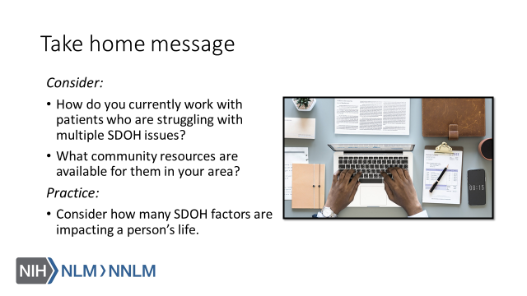

References:
- Conrad, CD (2008). Chronic Stress-Induced Hippocampal Vulnerability: The Glucocorticoid Vulnerability Hypothesis. Reviews in the Neurosciences, 19(6), 395–411.
- Schofield, H, Schilbach, F, and Sendhil M. 2016. "The Psychological Lives of the Poor." American Economic Review, 106 (5): 435-40.DOI: 10.1257/aer.p20161101
- McEwen, BS (2017). Neurobiological and Systemic Effects of Chronic Stress. Chronic Stress (Thousand Oaks, Calif.), 1, 10.1177/2470547017692328.
- Lu, MC, Halfon N. Racial and ethnic disparities in birth outcomes: A life-course perspective. Maternal and Child Health Journal. 2003;7(1):13–30.
- Djuric, Z., Bird, C., Furumoto-Dawson, A., Rauscher, G., Ruffin, M., Stowe, R., Tucker, K., & Masi, C. (2008). Biomarkers of psychological stress in health disparities research. Open Biomark Journal, January 1: 7-19. Available at: URL to Source
- McEwen BS. Stressed or stressed out: what is the difference?. J Psychiatry Neurosci. 2005;30(5):315–318.
- Feinberg, C. (May-June 2015). The Science of Scarcity. Harvard Magazine. Retrieved from: URL to Source
- Novotney, A. (February 2014). The Psychology of Scarcity. Monitor on Psychology. Retrieved from: URL to Source

