Hi everyone,
Thank you for participating in our seventh motivational interviewing Clinical Conversation about the action stage. During our session, I mentioned that people in the action stage still may benefit from social support to keep going with a behavior change¹. I linked a document from NIH below that discusses the health benefits of social support. This could be useful for a patient who wants to learn about this topic. It also links associated research in the event that you would like more information. This link can be found on the Family Issues topic page in MedlinePlus. Please look these over if you have time!
Take care,
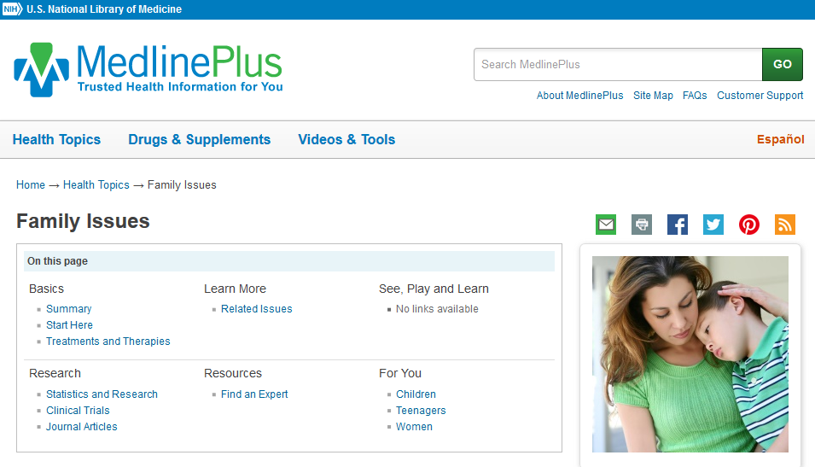

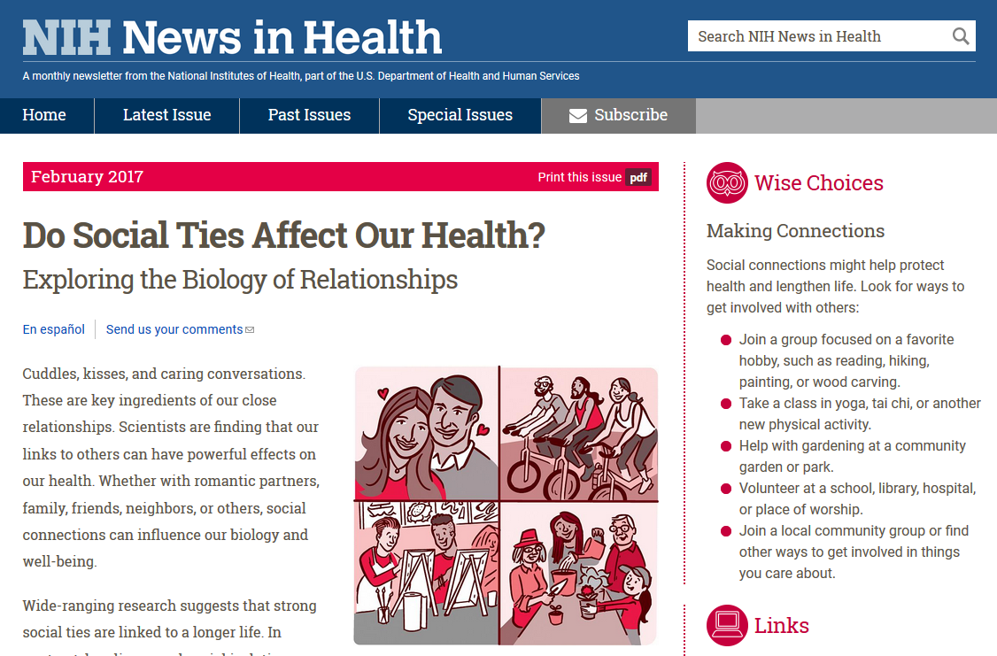

References:
- Constance, A. & Sauter, C. (2011). Inspiring and Supporting Behavior Change. United States: American Dietetic Association.

