Hi everyone,
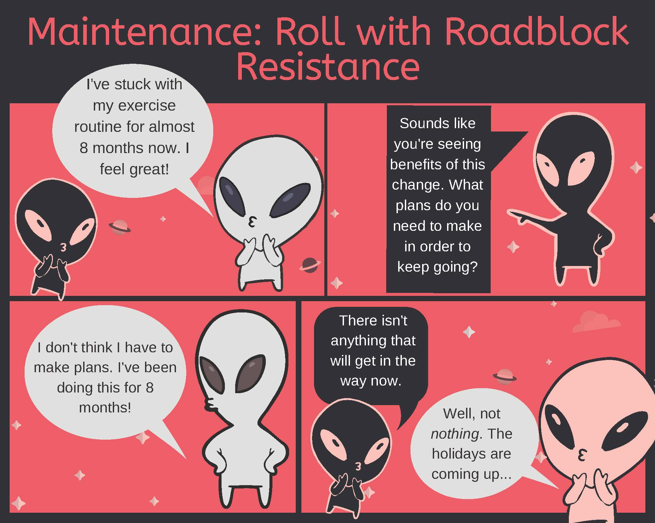
Thank you for attending our final Clinical Conversation about MI and the maintenance and relapse stages. During this conversation, we discussed different MI strategies for working with someone in maintenance. One of these was to roll with any resistance that a patient may have when you bring up planning for possible challenges¹. Here is a quick example of what this could look like.

Interested in more information about comics in healthcare? Check out NNLM’s education & information page about Graphic Medicine.
References:
- Tuccero, Railey, Briggs & Hull (2016). Behavioral Health in Prevention and Chronic Illness Management, Primary Care: Clinics in Office Practice, 43, 191-102. doi: 10.1016/j.pop.2016.01.00

