Hello,
Thank you for attending our Clinical Conversation [today, yesterday, etc.] about motivational interviewing in the precontemplation stage. One of the points discussed was that some patients in precontemplation may be in this stage because they lack information about risk¹. The module contained an example of how MedlinePlus can help someone understand the true risks associated with e-cigarette use. This page is linked below if you want to look it over again. In addition, MedlinePlus is a great spot for member of the public to locate trustworthy health information on other behavior change topics. For example, the topic page Health Risks of an Inactive Lifestyle might be good information for an exercise precontemplator, if they truly are in this stage because they lack information. As we discussed, people may also be precontemplative because they lack self-confidence in making a change¹.

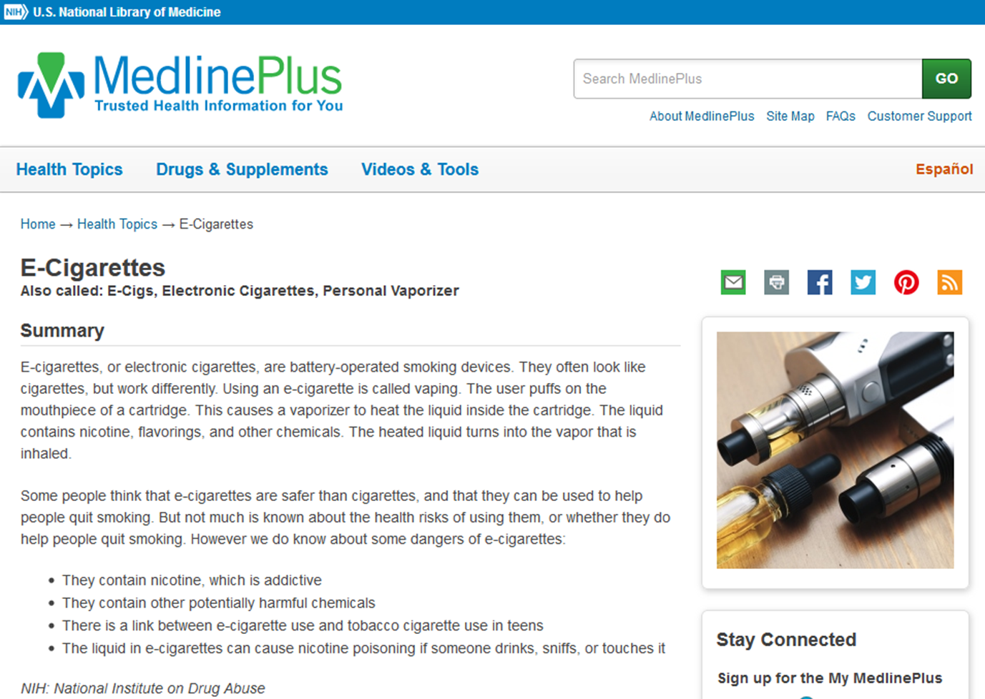

References:
- Constance, A. & Sauter, C. (2011). Inspiring and Supporting Behavior Change. United States: American Dietetic Association.

