Building Recovery Through Community

Information Resources
988 Lifeline for Crisis support – The 988 Lifeline is available 24/7/365. Your conversations are free and confidential. Call or text 988, or chat from the 988 website.
FindTreatment.gov is a confidential and anonymous resource for persons seeking treatment for mental and substance use disorders in the United States and its territories.
Resources from the National Library of Medicine

MedlinePlus
- Topic Page Index: Substance Use and Disorders: MedlinePlus
- Alcohol Use Disorder (AUD): MedlinePlus
- Prescription Drug Misuse: MedlinePlus
- Drug Use and Addiction: MedlinePlus
- Drugs and Young People: MedlinePlus
- Substance use disorders: Get the facts and find support | NIH MedlinePlus Magazine
- A better way to say that: Stigmatizing language affects how we treat addiction | NIH MedlinePlus Magazine
- 8 tips for talking (and listening) to your teens about drugs and alcohol | NIH MedlinePlus Magazine
- How naloxone reverses opioid overdoses (and why it’s important to have on hand!) | NIH MedlinePlus Magazine

Resources from NNLM

NNLM Reading Club
Substance Use Disorder | NNLM
Alcohol Use Disorder | NNLM

NNLM Classes and Guides
NNLM Public Libraries Guide, Behavioral and Mental Health
October 9, 2025 NNLM Class Providing Mental Health Resources at Your Library
Subscribe to the NNLM Weekly Class Announcement Email
Sign up for the NNLM Region 7 weekly newsletter

Other Resources
Find Support | SAMHSA provides a variety of supporting resources.
SAMHSA has many Resources to Support Individuals and Families such as Talking to Kids About Alcohol and Other Drugs: 5 Conversation Goals [SAMSHA PDF 2 pages] and Supporting a Loved One Dealing with Mental and/or Substance Use Disorders: Starting the Conversation [SAMSHA PDF 1 page].
What CDC is Doing | Overdose Prevention | CDC
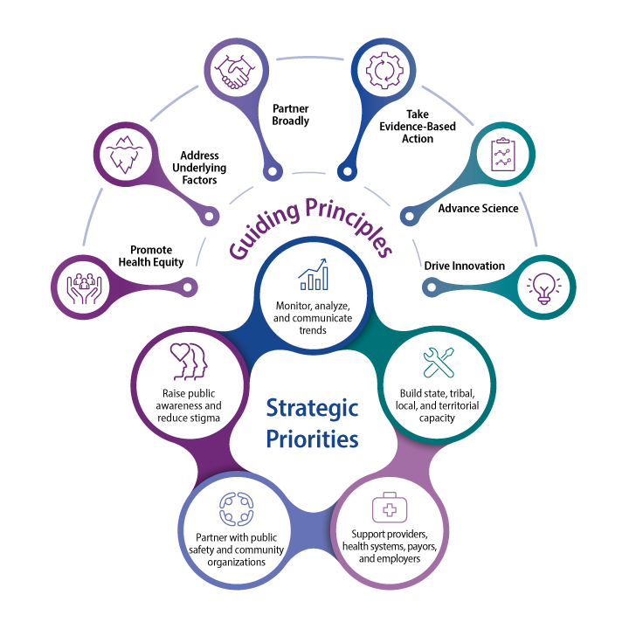
Drink Less Campaign | CDC
Drug Take Back Locations
Health Topics: Alcohol Use Disorder | National Institute on Alcohol Abuse and Alcoholism
Words Matter When Discussing Alcohol Issues: A New Stigma-Free Vocabulary for Better AUD Outcomes - News from the National Institute on Alcohol Abuse and Alcoholism

Specific Resources from Presenters
Read to Recovery @ SSPL - Recovery & Addiction Resources - LibGuides at Saratoga Springs Public Library

Riverbend
Recovery Coach Trifold May 2025
MA CARC Training Requirements
Riverbend CCAR RCA Flyer
Riverbend RSS Programs

NNLM Member Spotlights
Riverbend’s funded project expands the Recovery Coaching workforce and reach in Massachusetts
Emily Martin and Mary Ratzer from the Saratoga Springs Public Library are bringing resources to support recovery to their community

