Slide 1
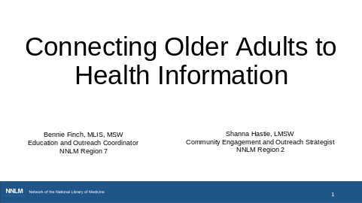
As people file into the class:
Please share your field or type of organization you work for in the chat.
Welcome everyone. It’s the top of the hour so we’re going to get started.
Shanna: Hello, my name is Shanna Hastie and I am the Community-Engagement and Outreach Strategist for Region 2. We are located at the Medical University of South Carolina in the Colbert Education Center and Library in Charleston, SC.

Bennie: Hi everyone! My name is Bennie Finch. I am one of the Education and Outreach Coordinators with the NNLM in Region 7. We are located at the University of Massachusetts Chan Medical School in Worcester, Massachusetts.

My name is Rebecca Brown and I’m a training development manager for the NNLM Training Office. We call it NTO. We’re located at the University of Utah. Now I’ll turn it back over to Shanna.

Today we’ll be talking about connecting older adults to health information. This training is designed to support the needs of libraries, public health workforce, nurses, and community-based organizations.

Before we get into the presentation, I have a few housekeeping items to cover.

Captioning is available by clicking the Show Captions button.

We’ll be sending out the recording to all registrants within the next couple of weeks
And, at the end of today’s session we’ll share the evaluation link, which is the first step in claiming continuing education credit.

Today we want to highlight the on-going work of libraries to support older adults and ways that other professionals might consider partnering with libraries. Libraries provide:

access to computers and digital literacy training helping patrons connect with family, friends, health information and government services provide opportunities for older adults to share their expertise through special programs, reading groups, volunteering and mentoring engage patrons who have mobility and transportation issues, providing service in senior centers and nursing homes or through virtual programming and home delivery services or book mobiles provide a safe, comfortable, and inviting setting at which older members of the community are treated with courtesy and respect offer opportunities for intergenerational activity that engages the whole community

From: seniors.pdf
https://www.imls.gov/sites/default/files/publications/documents/seniors.pdf

Slide 2
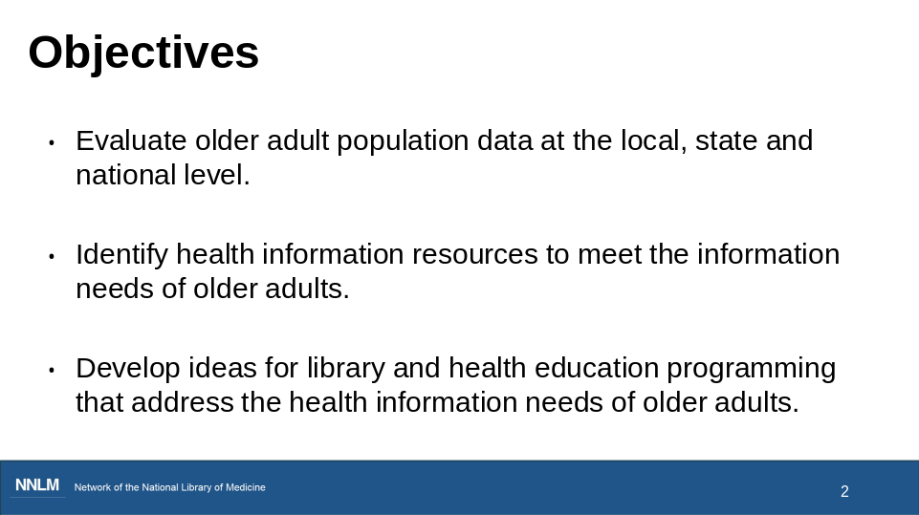

Let’s look at our objectives. Today’s presentation is going to cover:

Evaluating older adult population data at the local, state and national level.
Identifying health information resources to meet the information needs of older adults.
And also, we’ll look at developing ideas for library and health education programming that address the health information needs of older adults.

Before we go any further, I’m going to pass this over to Rebecca for a quick Zoom poll.

Slide 3
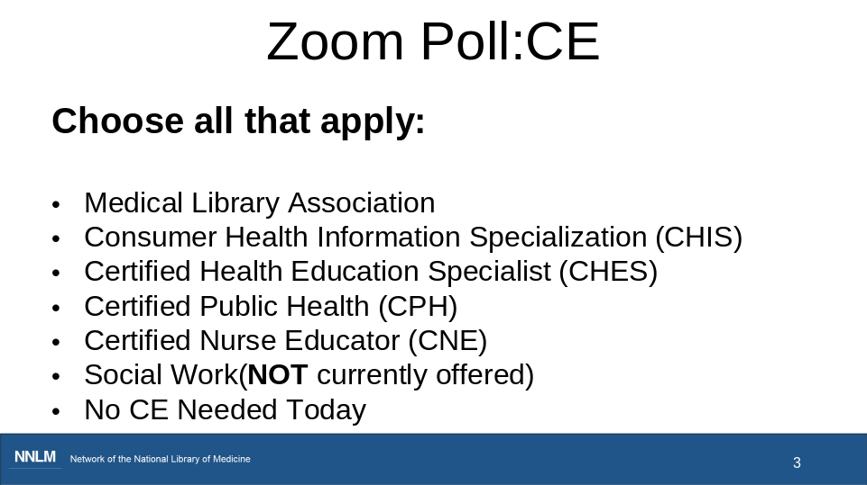

Before we get started with today’s content, I’m going to open a Zoom poll. We’d like to know what type of continuing education credit you’re interested in today. We offer all the types you see on the slide. You can choose all that apply.

Alright, I’m going to close the poll. Thanks for participating. We appreciate the information. I’m going to turn it over to Shanna again.
CE categories
MLA CE
CHIS
CHES
CPH
CNE
Social Work CE (Not currently available)
No CE Needed Today

Slide 4
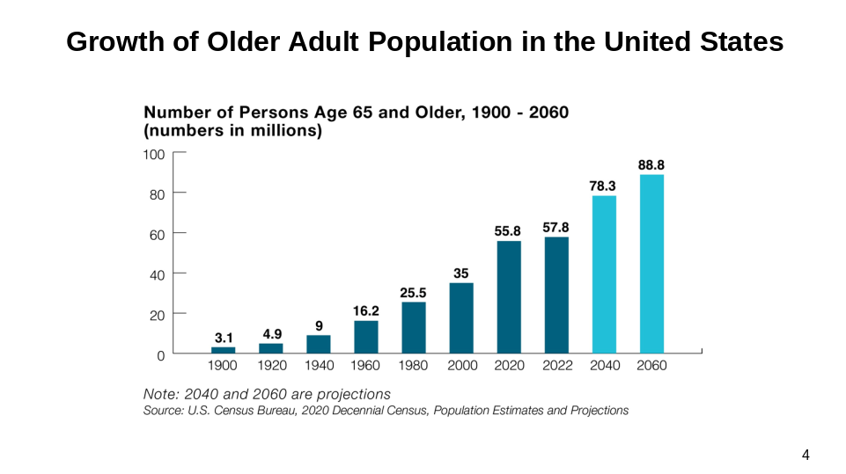

Shanna

Let’s start with some population data. I’m sharing this graph created by the administration for community living taken from the 2022 census data to quickly demonstrate the growth in the number of older adults in the united states over the past century. In 2022 there were almost 58 million older adults in the united states.

- Of the approximately 330 million people in the US in 2022, 57.8 million were 65 and older, including:
- 32 million women and 26 million men were 65 and over
- People 65 and over-represented 17.3% of the population
- the projected estimate by 2040, is that 22% of the population will be 65 or older
- In fact, 4% are expected to be 85 or older

Image is from https://acl.gov/sites/default/files/Profile%20of%20OA/ACL_ProfileOlderAmericans2023_Graphics.zip

Slide 5

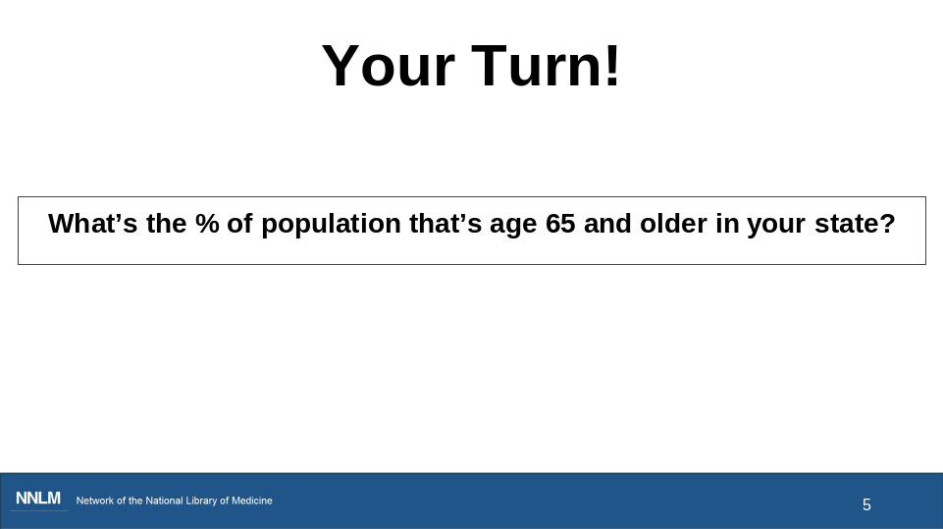

Shanna

Now I want to give you a chance to look at the percent of the population in your state that are 65 and older.

Rebecca is putting a link into the chat box, it’s also on your handout .
After you have the spreadsheet open, look at the bottom of the spreadsheet, there are several tabs.

Choose the tab “state percent 65+”.
Let me know which state you are from and the percentage of the population over age 65 in your state in the chat.

(Pause, wait for a few responses to come in)
Thank you for sharing the information about your state in the chat.
https://view.officeapps.live.com/op/view.aspx?src=https%3A%2F%2Facl.gov%2Fsites%2Fdefault%2Ffiles%2FProfile%2520of%2520OA%2FACL_ProfileOlderAmericans2023_DataTables.xlsx&wdOrigin=BROWSELINK

Slide 6

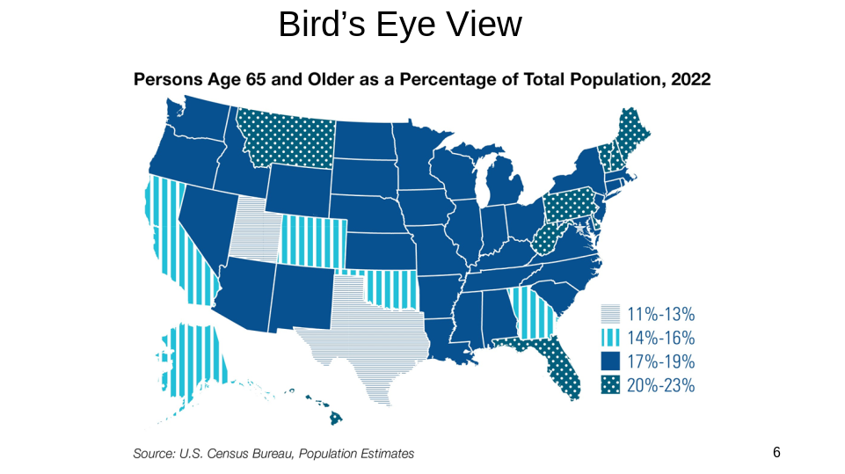

Shanna

So, we’ve looked at our individual states. Here’s a snapshot of the percentage of the population of older adults across the entire United States in 2022.

The percentage of older adults varies from 11% in some states to 23% of the population in others.

Now, I’m going to turn it over to Bennie and she’s going to demo a couple of websites that can provide health data regarding older adults in your county and more.

Slide 7
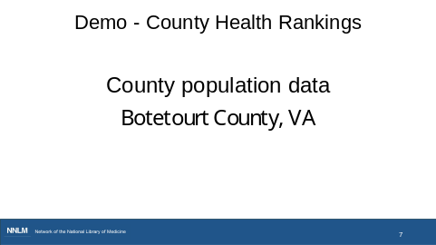
Bennie

Now that we have a sense of the older adult population by state, I find it helpful to get a sense of my local information as well. I would like to demonstrate 2 different sites. We are going to take a look at Botetourt County Virginia. I chose this county because this is the county where I grew up.

The first site is County Health Rankings and Roadmaps. I like this site because we can see the data at the county level.
(accept cookies)

If we start here at the health data tab at the top, we can choose Health Data by Location.
So here, we could either use the map to choose our state, or I'm going to put in the county.

I'm interested in Botetourt County, Virginia, so I'm going to choose that option.

Here we find a map with the location of the county and the state of Virginia.

And there's some basic information below related to health behaviors and health outcomes. You can explore these data points for your own county later, but I'm curious about the demographic data for the county specifically.

So, I'm opening this tab, called Show Demographic Data. And here I find the percentage of the population that's 65 and older. (make font bigger – ctrl +)

For the state of Virginia, that percentage is 17.2%, but for the specific county, it's 24.6%.

So here you can get a sense of some variability of the percentage of the population in different parts of the state

Slide 8
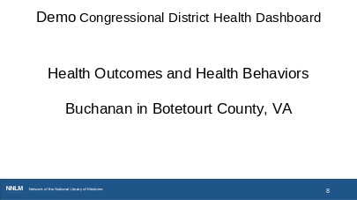
Bennie

Now I'd like to take us to a different resource called the Congressional District Health Dashboard.

This is going to cover a slightly larger geographic area.

This time I'm going to enter a street address,

19795 Main St
Buchanan, VA 24066. This is the address of the Buchanan Library in Botetourt County which is the same County in Virginia we looked at earlier.

Now I am going to view the district. So here we see a variety of health metrics, and this is going to be for that entire district, not just for the county.

One key thing to know is that this health information is for all ages, not just older adults, but it is still useful for planning purposes and to explain why you might be choosing this activity or resource for your organization.

So here, we can choose from the different filters. I'm curious about health outcomes.

When I choose this, I get a list of specific metrics.

So, these are some things I might want to pay attention to when looking for programming ideas.

Health behaviors is another metric that I might want to consider when planning for my organization.

Slide 9

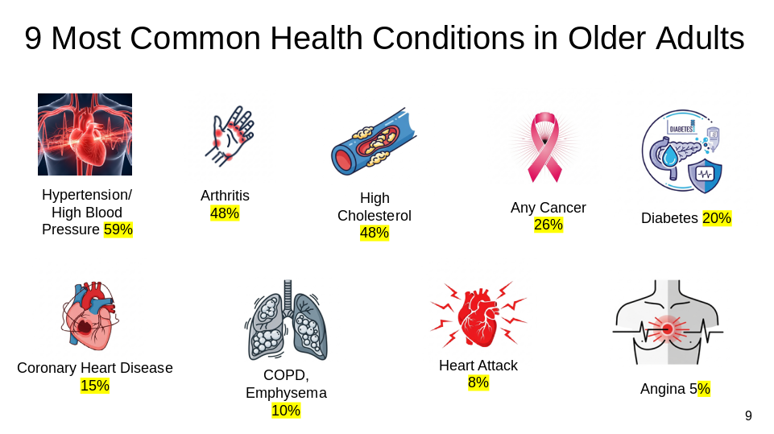

Bennie

We noted some health indicators in the County Health Rankings and Congressional District Health Dashboard. There are also some common health conditions in older adults nationally.

This list of the top 9 most common health conditions in older adults in the United States is from the 2023 Profile of Older Americans developed by the Administration for Community Living.

You may notice some common themes. Hypertension, high cholesterol, and coronary heart disease are all related to the heart and circulatory system. Arthritis and diabetes are chronic illnesses. We also see cancer and respiratory issues here.

So, now that we’ve looked at sources of health data about our state, counties and more local data, we have some ideas about health issues. So, now, let’s take a look at some information resources you can use to answer questions or share with library patrons.

Source:
https://acl.gov/aging-and-disability-in-america/data-and-research/profile-older-americans

Slide 10
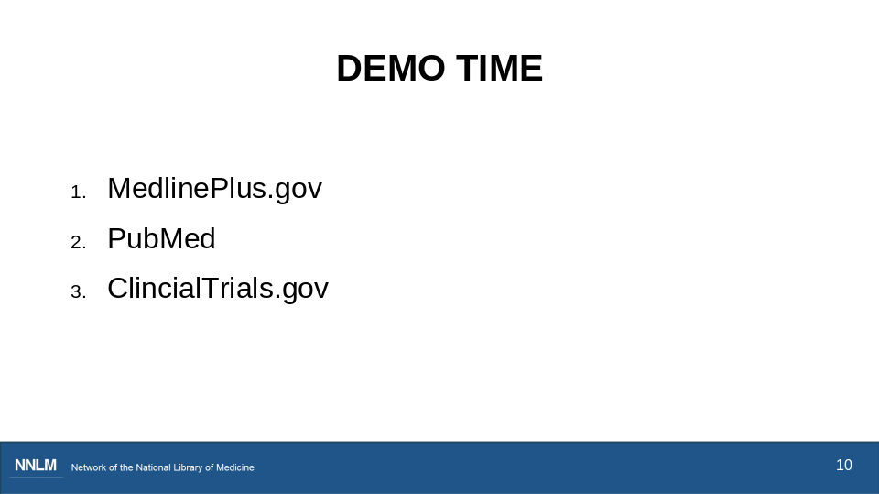

Bennie

MedlinePlus.gov Demo

I imagine that many of you are familiar with MedlinePlus.gov. It's one of the premier products from the National Library of Medicine. The National Library of Medicine is one of the National Institutes of Health, which is funded by our tax dollars. I'm not going to spend a lot of time going into all the details about MedlinePlus and what's available here. We have other classes and tutorials that go into more depth about MedlinePlus, and we have links to those classes on the handout. Today I want to focus on finding information for and about older adults.

So, across the top here, we have our main navigation. I want to point out that you can turn the entire site into Spanish by using the Espanol button on the upper right corner of the page. So that’s great if you’re working with Spanish-speaking individuals.
We sometimes get questions about how MedlinePlus is translated into Spanish. The MedlinePlus Spanish Team is made up of individuals who are native Spanish speakers and have experience in health, medicine, and biological sciences.

If we look at the navigation bar across the top of the page, Health Topics is a great place to start, and we also see a link to Medical tests.
I'm going to scroll down to the center of the page; we have the same navigation choices here.

And then below that on the left side, there's a link to easy-to-read health information, and that would be for all ages.

Health information in multiple languages, again, this is for all ages. And then a link to clinical trials, which we’ll come back to a little later.

I’m going to click on Health Topics.
There are a variety of ways to search or browse this page.
I’m going to choose Demographic Groups on the right side of the page.
Here we see our target population, Older Adults.

When I click on that link, I’m taken to a page with approximately 200 health topics that address common health concerns of older adults. (scroll slowly)
There’s an arrow on the bottom right side of the page that will jump me back to the top of the page. So, I’m going to use that to get to the top, because my preferred way to find a specific topic is to enter it into the general search box in the upper right corner of the page.

Now I’m going to type in high blood pressure, you could also search for hypertension, and when I run this search, the top result is high blood pressure.

We have some other results listed here about our topic. You can see where the information comes from by reviewing the URL.

I'm going to click on the main high blood pressure link, and it takes us to what MedlinePlus calls a topic page.

All topic pages are laid out the same way. There’s a table of contents in the box at the top, that includes a summary of the topic, a start here link and videos & tutorials on the right.

A couple of things I want to show you here are on the right side of the page. There’s a medical encyclopedia that pulls in related links to additional information.

(Scroll down) Here are some of those start here resources. There is a link to an article marked easy to read. Anytime you see this NIH logo that indicates the resource is coming from one of the National Institutes of Health. There is also a resource from the American Heart Association.
Scrolling down there are diagnosis and tests (scroll slowly) and a number of other resources.

I also want to point out what those multilingual resources look like. So I mentioned that MedlinePlus is available in Spanish. IN addition to this there is a selection of resources that are available in languages other than English and Spanish. (go to link on page). Here we see this handout is available in 12 languages (demo Arabic).

Notice in the Research section there’s a link to patient handouts which can be emailed or printed. These are available in both English and Spanish. We find that nurses are often particularly interested in these resources for patient education.

Alright, so I’m going to use the arrow to jump me back to the top of the page. I know we have a number of people who work in public health and may want to do their own research of the medical literature or a librarian who might assist someone who wants to research the medical literature.

When appropriate, MedlinePlus includes a link to Journal Articles. We see that in the research section. When I click on the link, I’m dropped down to the section that includes 3 free full-text articles on the topic. The last link in the journal articles section says see more articles. When we click on that, a search is launched in PubMed.

Are there any questions about medlineplus before we head over to PubMed?

PubMed Demo

PubMed is a biomedical research database and it’s another product of the National Library of Medicine, and it’s for anybody in the world who wants to research the medical literature.

If you look at the search box at the top of the page, you can see exactly what and how PubMed performed the search. We see a very long search string.
In order for us to get a better view of the search string I'm going to click on the word Advanced that's below the search box. And it takes us to the advanced search builder page. And if you scroll down to the history and details section, we see the search that was run even though we started in MedlinePlus.

We see terms like prehypertension, hypertension, last year, we see a few publication types that were included in our search, such as patient handouts, guidelines and clinical trials. We also see free full-text, which means that your library doesn’t have to subscribe to the journal to access the article.

I’m going to go back to our search results by clicking on the hyperlinked number in the history section. And that takes us right back to where we started. Now this is a very broad search, and older adults isn’t part of the search. On the left side of the page we have filters. And I’m going to click on Additional filters. Here we see that we can choose our age group. I’m going to choose 65 plus and we’ve gone from ____ results to _____. You can apply multiple filters.

We don’t have time today to do a deep dive into PubMed, but we teach a 3-part webinar series called How PubMed Works. Each webinar is 90 minutes. We just taught these in November and the recordings are posted in the NNLM YouTube channel. The classes are also available on-demand. And we have another on-demand class called PubMed Essentials. We’ve included registration links on the handout.
One of the things I’d like you to take away about PubMed is that you can just add your keywords to the search box and retrieve relevant results and search details will show you exactly what and how PubMed searched for your topic.

Are there any questions about PubMed before we move on?

Now I want to show you one more resource from the National Library of Medicine and I’m going to use the MedlinePlus page we started at as a jumping off point. So, now we’re back on the high blood pressure topic page. You may get a question about clinical trials.

ClinicalTrials.gov Demo

This particular MedlinePlus topic has a link in the research section called Clinical Trials.
So, I'm going to click on that link, and we’re dropped down to that section on the MedlinePlus page.
[DO] The first link runs a search on high blood pressure in the clinicaltrials database. We also see a link for pre-hypertension. I’m going to click the first link to run a search on our main topic.

ClinicalTrials.gov is a website and online database of clinical research studies and information about their results. The purpose of ClinicalTrials.gov is to provide information about clinical research studies to the public, researchers, and health care professionals. The U.S. government does not review or approve the safety and science of studies listed on this website.

We teach an entire class on this website called Clinicaltrials.gov for Librarians, but of course, anyone can register. The class provides a deep dive into the website. We’re teaching that class in January and we put a link to the registration page on the handout, if you’d like to register. We also have a class that’s offered on-demand, and we put that registration link on the handout as well.

The results we see [POINT: viewing 1551 studies] are for not yet recruiting and Recruiting trials because that’s what the MedlinePlus search included. You see our topic hypertension is in the Condition/Disease box, and you can add your location to the left-side panel .

You can amend the original search by using the filters on the left, such as:
Eligibility, male, female. Age ranges, older adult is listed here. [DO] APPLY OLDER ADULT LIMIT, and I’m going to scroll back up to the LOCATION box and add HOUSTON. Now we have a list of 26 results.

Alright, so that’s all I’m going to cover in the demos of MedlinePlus, PubMed and ClinicalTrials. As I said before, we teach classes about each of these resources and those links are on the handout.

Are there any questions about clinical trials.gov before we move on?

(pause)
Great! I will pass it over to Shanna

Slide 11

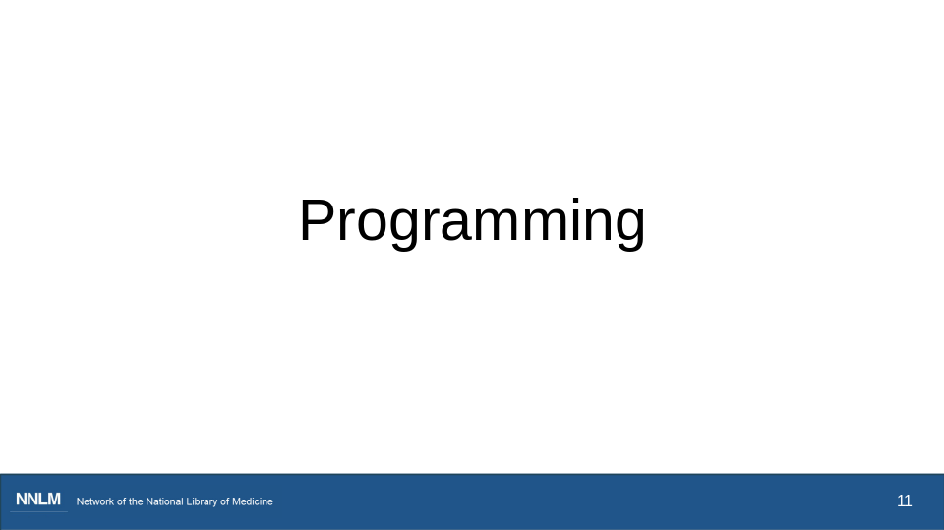

Shanna

Now let’s transition into our discussion of programming ideas to consider. Where do we start?

Slide 12
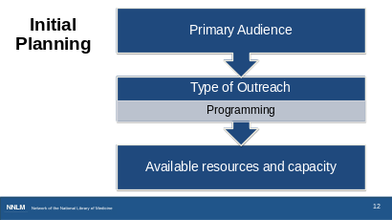
Shanna

We are going to start with our Initial planning which will take in consideration our primary audience, type of outreach and available resources and capacity.

We’ve already initiated the discussion of some resources to determine your community health needs and some information resources.

As well as, you have the resources to learn about older adults in your area, and we have reviewed several informational websites and databases.

Now you’re at the stage where you would identify your intended audience. This may be a specific group of older adults with a specific health condition, such as Type 2 Diabetes.

Next, consider the type of outreach or programming that is appropriate for this audience.

Keep in mind, health outreach does not mean that you have to provide a one-hour program with a speaker and activities. Think about the spectrum of engagement --- and what a manageable and meaningful outreach activity might look like based on your audience’s needs.

It might be highlighting particular information resources, such as MedlinePlus; it might be offering one-time programming or a series; or it might be offering some training.

Finally, consider the staff capacity and physical space you have available, and other factors.

On the National Library of Medicine’s website listing of available courses; we have a class called Health Programming at your Library. We have a link to information about it on the handout.

Slide 13

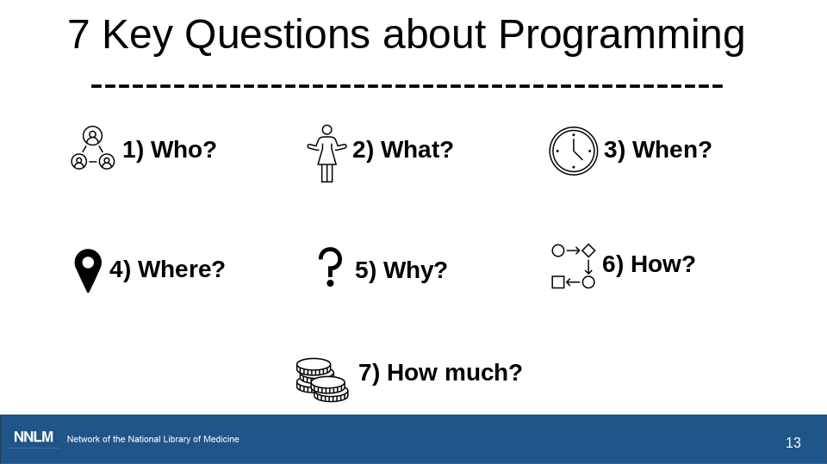

Shanna

Here are the 7 Key Questions to ask regarding programming, the who, the what, when, where, how, and how much. This slide provides a blueprint of questions to consider for your programming. These questions are all multifaceted but will help you recognize what pieces you have in place and where you will need to fill in the gaps.

Slide 14

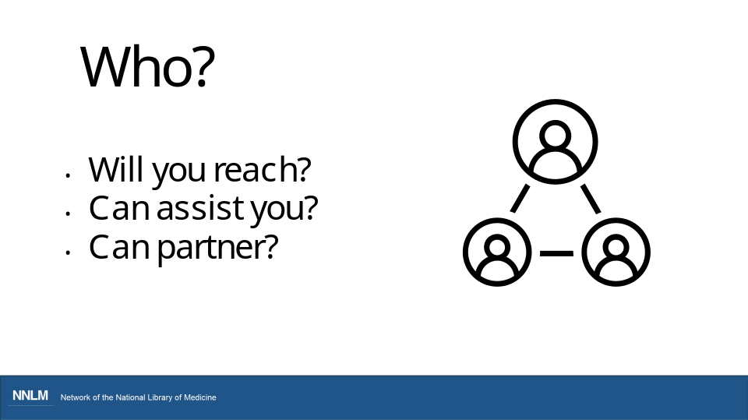

Shanna

Who? Think about who your primary audience will be? Who in your organization can assist in the planning and the program? Who else should be at the table? Who in your community might be an expert or might know an expert? Who are potential partners for this outreach event?

Slide 15

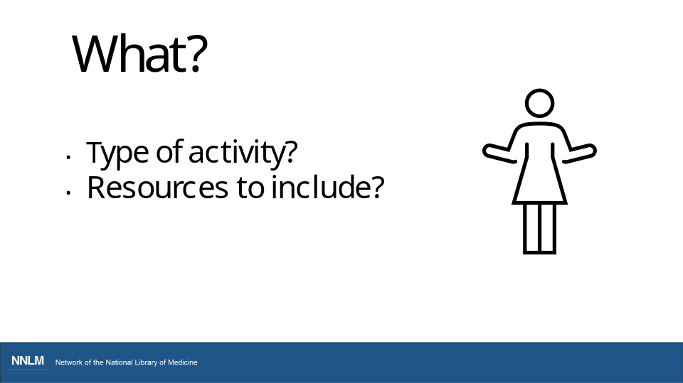

Shanna
What? What type of outreach activity do you wish to provide? Will you provide information, or will you offer a program with a speaker? What are the community health needs and what evidence of this do you have? What resources are available from the National Library of Medicine or other agencies that you can use?

Slide 16

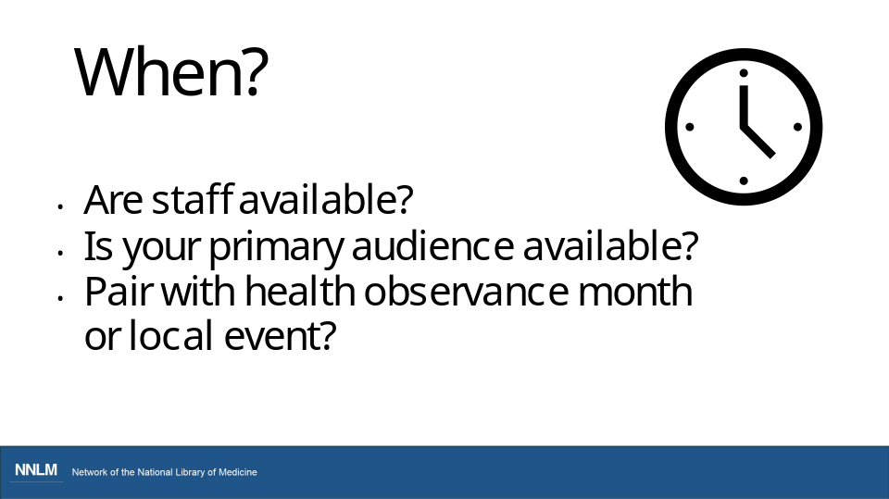

Shanna
When? When will you offer your program? When should you schedule program so that your audience and staff are available? Will this be a one-time or ongoing event? Should it coincide with a health awareness month or initiatives within your community?

Slide 17

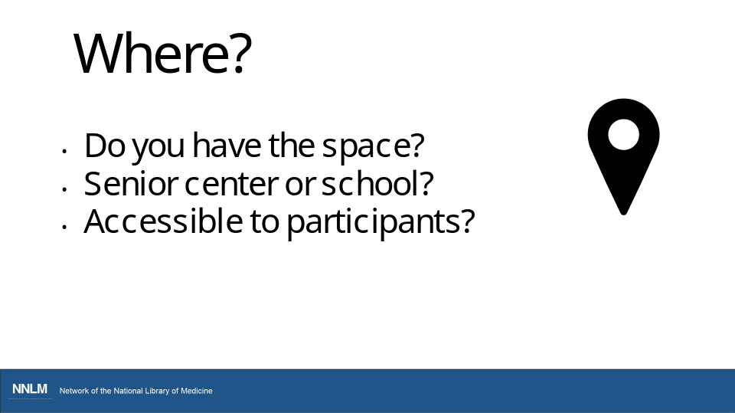

Shanna
Where? Where will the program be held? Do you have the space? Could this be outreach to a senior center or local non-profit? Is it accessible to the participants? Could this be an opportunity for your library to partner with an organization that may have resources that your library may not have at the moment such as a large auditorium space to accommodate the needs of participants?

Slide 18

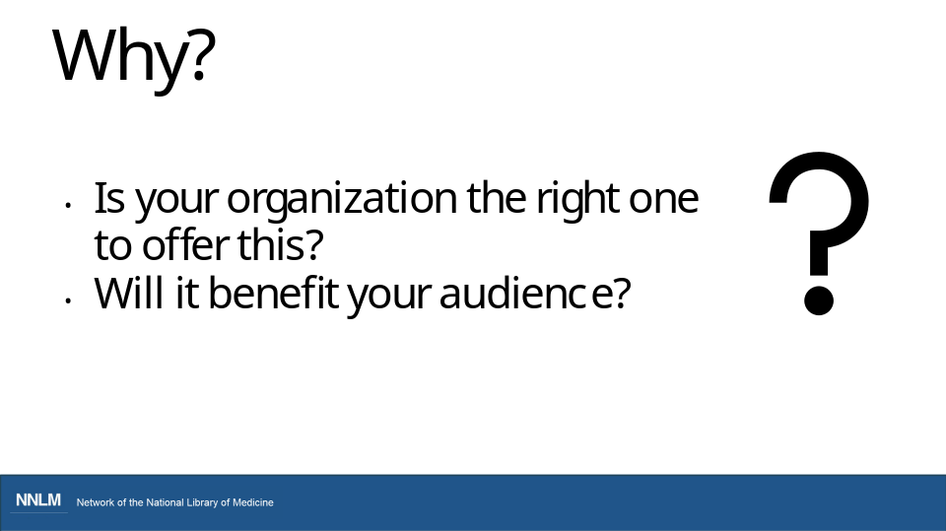

Shanna
Why? Why do you want to offer this outreach activity? Why will this benefit your library’s community? This is where those data resources can help guide you. Having the data to support the importance may help to procure funding and other support for your program

Slide 19

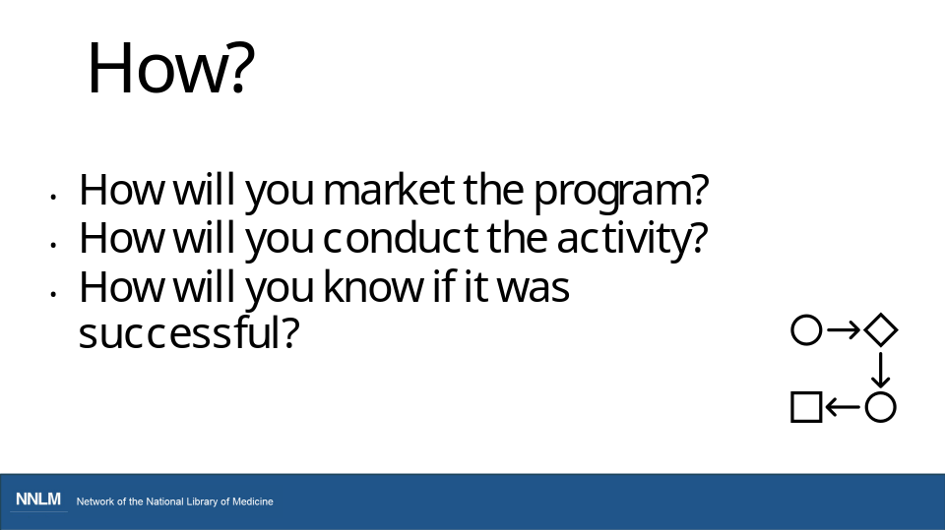

Shanna
How? How will you market the program? Will social media or flyers be included in how you advertise program? How will you measure impact of your program? For instance, will there be attendance taken, pre-post surveys, newsletter or social media posts?

Slide 20

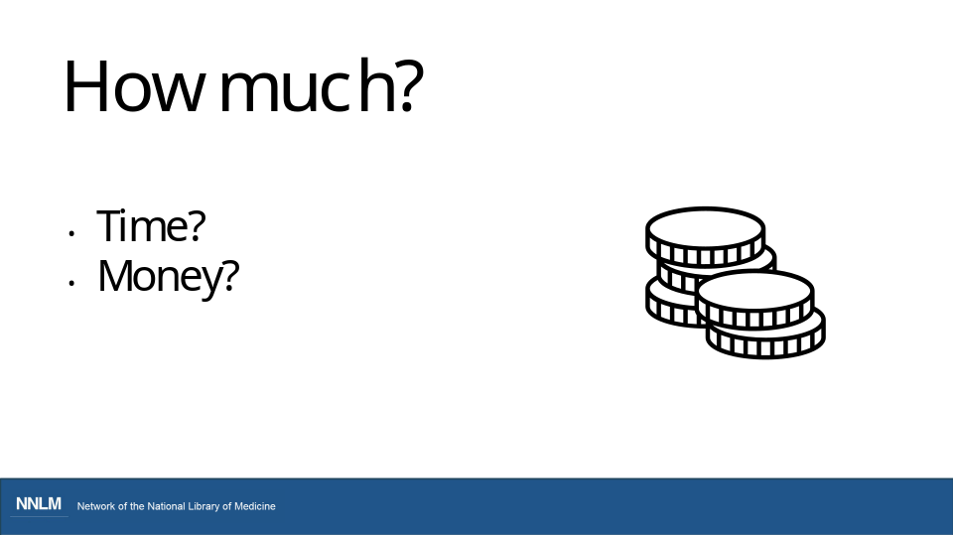

Shanna
How much? This question involves looking at how much time you and other staff will have to invest in the activity and how much money will it cost? Going back to costs. Are there partners who are willing to provide a program and/or space at no-cost. Is there grant funding available? Are there resources you can borrow from your state library or another library if you are part of a library system?
I want to let you know that we’ve included a couple of resources from the American Library Association that might help your planning process and we’ll discuss this a little later.

Slide 21

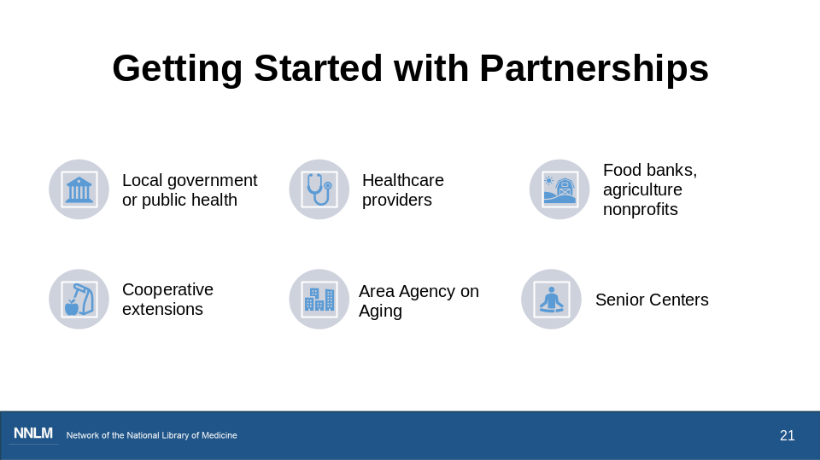

Shanna

Here we have identified some partnerships that libraries in our respective communities have collaborated with. In the chat, please feel free to share some partnerships that your library or organization have partnered with or suggest partnerships that would be ideal for working with older adults in your community. (pause)

Local government, public health agencies, healthcare providers, foodbanks, agricultural nonprofits, cooperative extensions, Area agency on Aging, and senior centers, all provide valuable resources that may have the expertise, audience experience, materials or other resources that your program needs for success.

With an audience and idea in mind, begin to think about who you might be able to partner with to enable or enhance the outreach or programming activity, and does this partner or organization align with the overarching goals and objectives of your organization.

Additionally, libraries as the program hub for partnerships, could serve and provide a platform to expand the population reach of your programming goals.

Slide 22
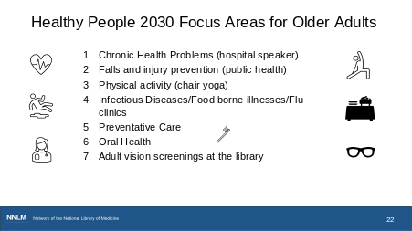
Shanna

In the first section of today’s presentation, we reviewed the Congressional District Health Dashboard to gather health metrics by district and some common health issues among older adults.

Healthy People 2030 is another resource that we would like to highlight as we think about programming and some health topics you might consider. Healthy People 2030 is an ongoing project by the Office of Disease Prevention and Health Promotion.
Healthy People 2030 sets measurable national objectives with 10-year targets to improve the health and well-being of all people. Twenty of those objectives are specifically focused on reducing health problems and improving quality of life for older adults.

The first Healthy People initiative started in 1990 and is updated every 10 years with health goals and metrics to focus on and track for that decade. Some metrics continue across decades, but priority areas change over time to meet the current health concerns.

We thought by looking at the categories specific to older adults identified in 2020 for Healthy People 2030 this might also provide some ideas for programming.
I am sure that you have noticed information requests and needs from your patrons regarding a number of these health concerns on the slide.

Can you share in the chat some programming ideas for these areas (i.e. oral health)?

Great, thanks for adding your ideas to the chat. (If needed, possible ideas could be hosting vision screenings at the library, hosting a program on food safety, possibly have a health care professional offer blood pressure screenings)

Now Bennie will talk about Programming.

Slide 23
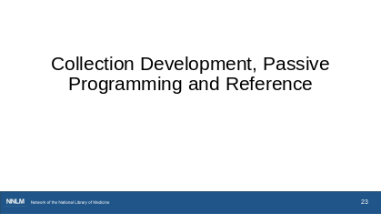
Bennie

Thanks, Shanna!
The first type of programming I would like to go over is collections, passive programming and reference. Consider starting with a review of your library’s current collection and seek items to fill any gaps.

When we discuss passive programming, what we mean by that, are self-directed programs. This could be things like having a poster in the bathroom about handwashing, having coloring pages out on a table, or posting a quote or question of the week. You might want to develop a book display for a specific event or awareness celebration.

You may also choose to provide free printed materials from organizations such as the National Institute on Aging. The National Institute on Aging has several publications you can download for free. We will look at some of those in a minute.

Maybe there are resources in your things collection you want to promote. Maybe your library offers take and make craft kits. I also hear about some libraries creating kits designed for patrons with dementia and their caregivers on a variety of topics for entertainment or to support reminiscing or connecting.

Reference is another important area. Curated lists of key or sensitive topics, and knowledge of community resources will be helpful here. Perhaps you want to create a LibGuide or list of resources. Being aware of resources may help you feel more confident when questions arise.

Slide 24
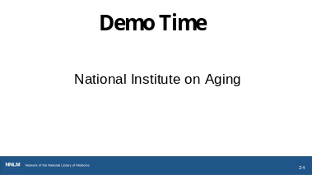
Bennie

Open these tabs ahead of time:

https://www.nia.nih.gov/
https://www.nia.nih.gov/health
https://order.nia.nih.gov/
https://www.nia.nih.gov/health/health-care-professionals-information
https://www.nia.nih.gov/health/caregiving
https://www.nia.nih.gov/toolkits
https://www.nia.nih.gov/toolkits/caregiving
https://www.nia.nih.gov/health/caregiving/take-care-yourself-caregiver
https://www.nia.nih.gov/health/healthy-aging/looking-health-information-older-adults-multiple-languages

The last site I want to demo for you is the National Institute on Aging, one of the National Institutes of Health. In addition to health information on selected topics, it has a lot of resources that could support programming at your library.

The national institute on aging has a ton of resources and you can follow a lot of different paths to get to the information. We have included direct links to the pages that we think are most important in the handout.
I am going to share some of those here, but don’t worry about following the specific pathways that I am going to demonstrate.

I want to go over a few details from this homepage.
I want to start by pointing out that this website is available in Spanish by clicking on the Espanol button.

Glancing at the homepage. There are choices in the navigation bar.
There's information on healthy aging, Alzheimer's, and more. we find information about funding opportunities, print publications. These are examples of items you can print for your library, or organization. These are things that you might hand out at an event, post in your library, or maybe have in a brochure rack.

You can browse health topics here,
– the first one is high blood pressure so let's take a quick look.
Going back, there is information on
aging research, resources for healthcare professionals, such as tips for improving communication, healthy aging.
And then here at the bottom of the page, there's also a link to Alzheimers.gov, if that's something that would be of help.

Now, going back to the top, Let’s start with this link for health topics, though you could find that in the navigation bar.

when we open this page, on the right side there are highlighted topics. If we scroll down, you can browse, A to Z. I just wanted to give you a sense of the number of topics that are available here that might be helpful or of interest when you're planning programming or supporting a reference question.
Each link goes to multiple resources for each topic like the high blood pressure page we looked at earlier.
(go back to top)
If we choose the publications for download link, there are featured publications here at the top but you can go to all, to see what's available that you might find helpful or interesting in your community or for your audiences. These are examples of items you can print for your library.

There are some also available in Spanish.
I wanted to point out this resource – The Caregiver’s Handbook. You can download a copy. On this page there are also some resources such as online health information, infographics and videos.

Going back to our health information tab (3 back arrows) we see Information for healthcare professionals.

I want to point out this multimedia toolkit, listed here as infographics, videos and more. There are lots of infographics here. (scroll)
Publications – we saw this caregiver’s handbook before.
Videos - Videos might be helpful for audiences who may prefer audio or video content over written content.
social media toolkits, scientific images and more.
Let’s review one of the social media toolkits. I am choosing social isolation and loneliness outreach toolkit. This is a robust toolkit, including animated graphics, social media images, social media posts, flyers, health information, videos and additional resources.
These are things that you might post on your library's website. Or include in a blog post or newsletter. Or, if you're putting together a LibGuide or other materials, these might be of use.

Heading back to the previous page - Let’s take a look at these infographics. We can view all infographics. Here are infographics on topics such as skin, or blood pressure, or clinical trials. This one I wanted to point out - take care of yourself as a caregiver. Because when we talk about older adults, we also think about caregiving.

This infographic - Take care of yourself as a caregiver offers some suggestions of ways that one might use to care for themselves, when they're caring for others. If we choose caregiving from the links on the left, we find even more resources. caregiver worksheets, that you can download, print, copy. Many articles for different topics related to caregiving.

And going back to that Health Topics A-Z page. Finally, those educational resources and toolkits
These toolkits are for caregivers, the general public, health care professionals, media and students. Let’s review the toolkit for caregiving.

(scroll) Again, some resources are highlighted that we have seen before such as Publications, videos, clinical trials. But I also want to point out that if we scroll down, there are resources for caregivers that might be helpful in terms of community resources. (slow down here)
These are some of the resources that could be helpful such as the Eldercare Locator or Area Agency on Aging.

And… last, I just wanted to point out that you can also look for health information for Older adults in multiple languages. Like MedlinePlus, NIA also has resources in multiple languages.

So hopefully these will be some great resources to use as you're thinking about your programming.
Are there any questions before I move on?

Ok, then I will pass it back to Shanna.

Slide 25

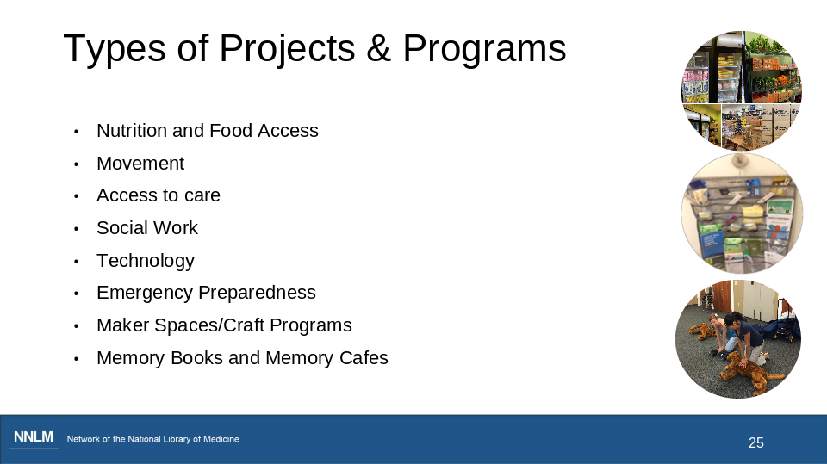

Shanna -

As we look at the types of projects & programs, we recognize that many of you have either conducted a myriad of programming ranging from nutrition and food access, access to care, social work or even memory books and memory cafes. We also recognize that there are some in this space that are still at the beginning phase of brainstorming ideas. This is a welcoming space for all, regardless of level of programming experiences. The hope is that through this conversation, we could help generate potential collaborations, provide libraries and organizations with additional resources in their tool kit to strengthen their established programming and or help others inquire about programs that could be replicated to meet the needs of the older adults they serve in their communities. Where can we find the synergy to work together? (I like to call this space making room for the magic.)

Slide 26
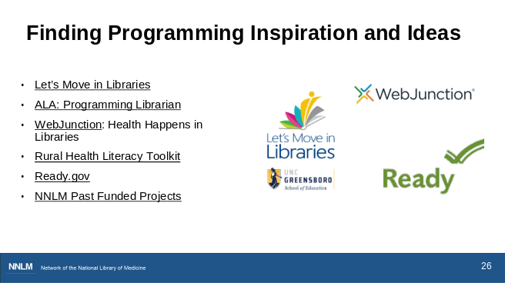
Shanna

Now if your wheels aren’t turning yet, we have more idea sources. But first, we would like to hear from you. Could you share in the chat about a program you have tried or one you are interested in trying?
(Pause for a few answers in the chat)

Still looking for ideas? You may find resources in those webpages from American Library Association (ALA) we mentioned. Our focus for this class is health information access, but there are lots of ideas for other types of programming as well. These programs may even have an impact on health as people experience social connections and meaningful experiences and interactions in the library.
I will briefly describe these websites,

Let’s Move in Libraries has program ideas, resources, and examples of library programming focused around movement and active living. Advice for where to begin, accessible programming, and liability.
Another resource from ALA: is the Programming Librarian – you can Browse and search library programming ideas. You might search by budget, by age group. Search for health. Get tips on planning, partners, marketing, budgeting, and other advice for carrying out the program.

WebJunction: Health Happens in Libraries – you can check out their resources list. This is less a list of ideas and more dedicated resources for you to develop health programming – including webinars, communication ideas, detailed examples of projects – it is a deep resource and very much worth exploring to make your health programming a lighter lift for you.

•Rural Health Literacy Toolkit: This clearinghouse is specifically dedicated to rural libraries, with a focus on health literacy

•Ready.gov: Emergency Preparedness training and programs; social media toolkits; older adults, people with chronic illnesses or disabilities, and people with pets may all have unique emergency preparedness needs to consider

•NNLM Past Funded Projects – this link has examples of projects funded by NNLM in the past. While we do not have funding available at this time, you may still find some ideas to consider from previous projects.

*While each website offers an array of great resources, due to time constraints we would like to take highlight two of the websites: Let’s Move in Libraries and Ready.gov.

Let’s Move in Libraries:

- Let’s Move in Libraries was an initiative that originated from the Let’s Move campaign of 2010. The Let’s Move in Libraries initiative provided grant-funded opportunities to libraries beginning in 2017 that focused on libraries and those within library settings that were responsible for developing programming focused on increasing physical activity and healthy eating programs, as well as, providing libraries with actionable steps to develop programming focused on overall health and well-being.
- As you navigate the program ideas, there are tabs available that help you access inspiration and review recommended actionable steps for successful planning. (Personal note: highlight tabs that Bennie hovers over.)
- One aspect of this website that we found insightful is that they included testimonials from libraries that participated in the 2019 Geri-Fit program for sustainable active living programs for older adults. Many times we do not get the opportunity to hear from our libraries regarding their experience of developing programs, but in this instance we have the opportunity to hear what those in libraries settings felt worked or what aspect of their program(s) they felt needed improvement. They also had the opportunity to share if they believed their programs could be replicated in other communities that served older populations.

- The Let’s Move in Libraries website also highlights the AARP Community Challenge Grants that provided annual funding awards to local projects that help make communities more livable for people of all ages. While there is currently no funding being offered for new projects, they have compiled various summaries of libraries that received funding in the past. This may present a strategic chance to see firsthand which libraries, potentially in your area(s) that have secured funding and help gather inspiration from the project models they implemented.

Now we will go to Ready.gov

- Ready.gov.
- On the Ready.gov website we are going to focus on the Emergency Preparedness Plan resources
- We are going to click on the tab “Make a Plan”
- Next we will find the tab for “Older Adults”
- Ready.gov can be viewed in both English and Spanish
- Under their plan for Emergency Preparedness they provide a checklist that you can review with thinking about experiencing an emergency personally or if you work with older adults. They also leave space for you to include additional items to your checklist because they understand the needs of you and/or your community can differ geographically, as well as, based on age and other differences

Slide 27

Shanna

Finally, we would like to share with you some health observances and awareness days that focus on older adults. Celebrating older adults with these monthly observances can further enhance programming, and some national associations and agencies provide additional information and toolkits to help bring awareness to health conditions and celebrate older adults that you can use. Some resources are free or low-cost to you.
(Remove?) You will be able to find the links to these observances listed above in the handout provided.

Image from @2hmedia https://unsplash.com/photos/a-planner-with-two-pens-sitting-on-top-of-it-cdDDWLezAJ0

Slide 28

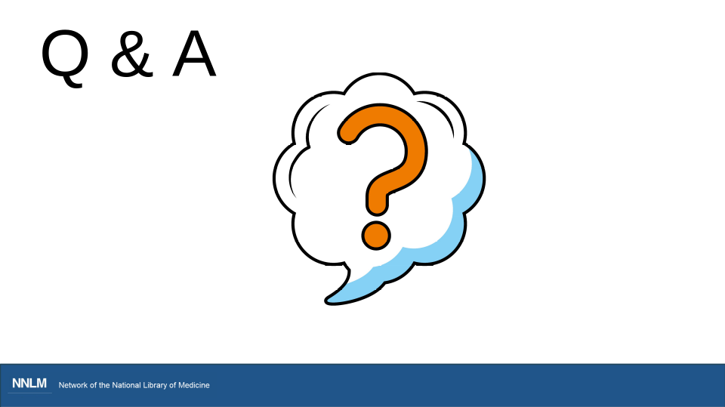

Photo by Uladzislau Petrushkevich on Unsplash

Slide 29

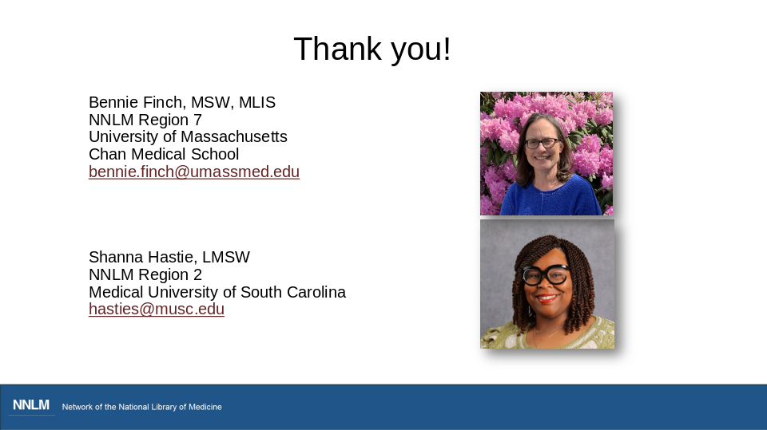

Here is our contact information if you would like to connect with us.

Slide 30

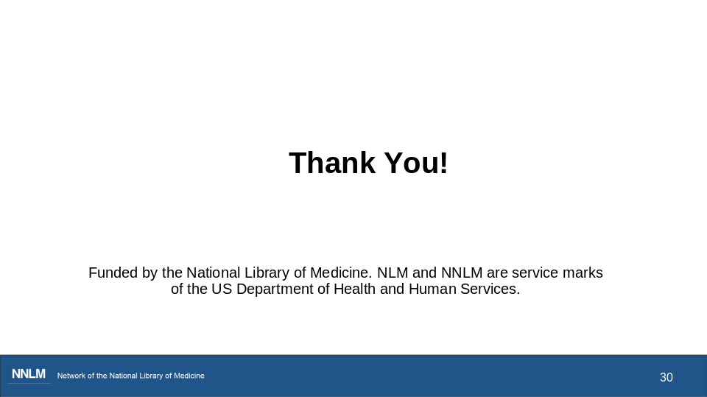

That’s the end of our content for today. The last thing we want to share is the link to the evaluation, which is the first step in claiming continuing education credit.

I’m going to pass the baton to Rebecca and she’ll wrap this up for us

Slide 31

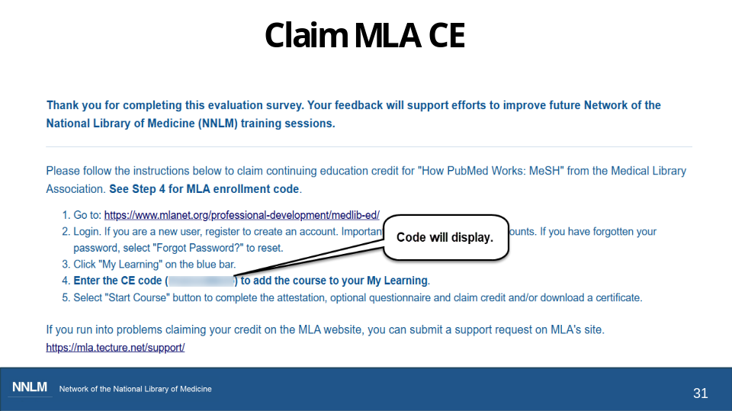

Rebecca

Thank you for joining us today. I’ve put the link to the evaluation into the chat box.

If you have questions about claiming the different types of CE, let us know in chat or you can email me at nto@utah.edu.

We’ve included a link to a 1-minute video on the handout that demonstrates how to claim CE on the Medical Library Association website.

