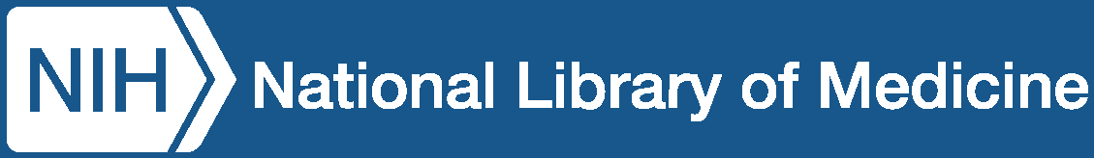

Tips for Using PubMed® pubmed.ncbi.nlm.nih.gov

PubMed is a free database of more than 40 million citations
For published articles in the fields of biomedicine and health
What is in PubMed?
PubMed has citation information (e.g., title, author, journal, publication date) and abstracts of published articles and books. PubMed includes the MEDLINE® database; citations for articles in the PubMed Central (PMC) free full text archive, including articles that report on research funded by the National Institutes of Health (NIH); and citations for books from the NCBI online Bookshelf (www.ncbi.nlm.nih.gov/books).
PubMed includes links to the full text from other sources, when available, such as the publisher’s website, the PubMed Central (PMC) archive, and subscriptions by your organization or local medical library, if they participate.
Use the search box at pubmed.ncbi.nlm.nih.gov for all directions described here.
Each bullet point described below is a method, not a step-by-step order of operations.
How to Search by Author

- Search by the author’s last name and initials (without punctuation).
- If you only know the author’s last name, use the author search field tag [au], e.g., baker[au].
- If your author shares a common name with others, find an article by your author of interest and click on the link of the author’s name. This function runs a “computed author” algorithm that groups articles most likely by your author of interest (based on co-authors, affiliation and topic terms) and brings them to the top of your search results.


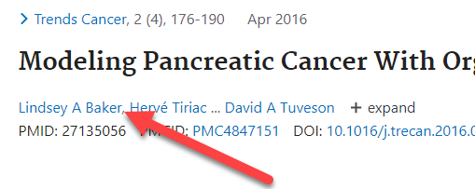
Click on a name to find other articles by this author

How to Research a Topic

- Enter your search terms into the search box
- Be specific
- Avoid quotation marks
- Avoid truncation (*)


PubMed will add relevant Medical Subject Headings (MeSH®), and other synonyms to improve your search. Use the “Advanced” function (found under the search box) to see your search details.
(Continued on next page)

How to Find a Known Article

- Search by article title. Copy the article title
into the search box.


- Enter the citation elements you have (author, title words, journal, volume, year, etc.) and let PubMed’s citation sensor find the article for you (e.g., nolte blood 2019).
- Use the “Advanced” function (found under the search box), to search by journal name.
How to Get the Full Article Text

- Free Full Text Filter
After you click “search,” a Filter Sidebar will appear on the left. Click "Free full text" to narrow results to resources that are available online for free, including PubMed Central, Bookshelf, and publishers' websites. Alternatively, include AND free full text[Filter] in your query.
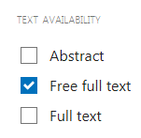

- PubMed Central (PMC) – www.ncbi.nlm.nih.gov/pmc/
When full text is available in PubMed Central, the "Free in PMC" icon will appear on the citation's abstract display under Full-Text Links. Click the icon to view the article in PMC. PubMed Central is the U.S. National Institutes of Health (NIH) free digital archive of biomedical and life sciences journal literature.
- From the Publisher
Journal publishers or related organizations may provide access to articles for free, for free after registering as an individual or guest, or for a fee. When available, icons linking to these sources can be found on the citation's abstract display under the "Full-Text Links" and/or "LinkOut" sections.
- Hospital, University, or Other Major Institution
If you are affiliated with a medical or academic institution, your institution’s library will most likely provide access to academic journals. When viewing an abstract, if you see icons for your library, this indicates that it provides a link to the article, has the journal in its collection, or may otherwise obtain the article through interlibrary loan. If your library does not have access to the article you need, ask a librarian about ordering the article from another institution.
- Local Public Library
Some public libraries have copies of medical journals or can get a copy of an article for you. Ask your local public librarian about interlibrary loan options and fees.
Where to Find Help
- PubMed User Guide and FAQs: https://pubmed.ncbi.nlm.nih.gov/help/
This online guide provides detailed directions for numerous search methods and database functions.
- Ask a librarian at your major research or education institution or at your public library.


National Library of Medicine
8600 Rockville Pike
Bethesda, MD 20894
https://www.nlm.nih.gov May 2026

