Universal Precaution for Health Communication
Research shows that screening patients for health literacy levels is not effective for improving communication⁷ and that even those who read at higher levels still prefer simple health information¹.
Universal precaution for health communication means communicating to everyone using clear communication strategies¹

Strategies for communicating clearly:
- Greet patients warmly
- Make eye contact
- Listen carefully
- Slow down
- Limit and repeat content
- Be specific and concrete
- Use plain, non-medical language
- Use the patient's words
- Demonstrate how it's done
- Show graphics
- Invite patient participation
- Encourage questions
- Apply teach-back¹

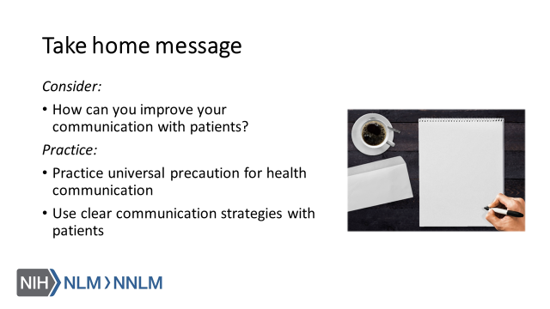

References:

- Brega AG, Barnard J, Mabachi NM, Weiss BD, DeWalt DA, Brach C, Cifuentes M, Albright K, West, DR. (2015). AHRQ Health Literacy Universal Precautions Toolkit, Second Edition. (Prepared by Colorado Health Outcomes Program, University of Colorado Anschutz Medical Campus under Contract No. HHSA290200710008, TO#10.) AHRQ Publication No. 15-0023-EF. Rockville, MD. Agency for Healthcare Research and Quality. Retrieved from URL to Source
- Broussard, I. & Kahwaji, C. (2019). Universal Precautions. Treasure Island (FL): StatPearls Publishing. Retrieved from: URL to Source
- Centers for Disease Control and Prevention (2016). Health Literacy Basics. Retrieved from: URL to source
- Howard, T., Jacobson, K. & Kripalani, S. (2013). Doctor Talk: Physicians' Use of Clear Verbal Communication. Journal of Health Communication, 18(8), 991-1001. doi: 10.1080/10810730.2012.757398
- Plain Language Action and Information Network (2017). Plain Language Guidelines. Retrieved from: URL to Source
- University of Michigan (2015). Plain Language Medical Dictionary. Retrieved from: URL to Source
- Hersh, L., Salzman, B. & Snyderman, D. (2015). Health Literacy in Primary Care Practice. American Family Physician, 92(2), 118-124.

